Delete and
replace with
school logo



BIRCHANGER C OF E (VC) PRIMARY SCHOOL

School Uniform Policy

July 2024

Review  Date | Reviewed  By Committee/FGB | Date agreed: | Next Review Date
July 2024 | FGB | July 2024 | July 2027

Birchanger C of E Primary School Uniform Policy
Aims
This policy aims to:
- Set out our approach to requiring a uniform that is of reasonable cost and offers the best value for money for parents and carers
- Explain how we will avoid discrimination in line with our legal duties under the Equality Act 2010
- Clarify our expectations for school uniform
Our school uniform
At Birchanger C of E Primary School we believe that children being relaxed and comfortable supports their mental and physical health and wellbeing, along with their ability to learn. The vision of our school is ‘Life in all its fullness‘ (John 10:10), and we believe that, in letting children come to school in ‘activewear’, they are able to flourish through being able to access all areas of the curriculum, including our Outdoor Play and Learning Programme (OPAL) during their play and lunchtimes. The decision to implement activewear was taken after consultation with our school community: pupils, parents, staff and the Governing Body. Admission to our school implies acceptance of our uniform policy.
Dress code:
Winter/All Year:

- Navy blue zipped fleece, cardigan or sweatshirt with the school logo (it is compulsory that all pupils’ tops have a school logo to identify them as part of our Birchanger Primary School community). These are available to purchase from School Trends, our online supplier. Please note no hoodies are allowed.

- Pale Blue Polo T-shirt – with/without the school logo (the t-shirt must have a collar).

- Activewear Bottoms – these should be navy blue and should be full-length leggings or jogging bottoms. These items should be unbranded.

- Socks – dark (black, blue, grey) or white.

- Footwear – sports trainers or shoes which children can run or do sport in. These should be black or predominantly black (please refer to Appendix A for guidance). Converse style shoes, plimsolls and football boots are not to be worn.

- Wellies – all children should have a pair of named wellies which can be left in school all year for Forest School or outdoor learning.

Summer:

- Navy blue zipped fleece, cardigan or sweatshirt (as previous) with the school logo on.

- Pale Blue Polo T-shirt – with/without the school logo.

- Navy blue cycling shorts (cotton – to just above the knee or halfway down the top leg), sweatshorts (no football or shiny shorts) or skorts. These items should be unbranded.

- Activewear Bottoms - navy blue leggings or jogging bottoms (as previous, unbranded)

- Footwear – sports trainers or shoes which children can run and do sport in (as previous see Appendix A).

Please note this uniform is also to be worn for PE and Forest School so no additional items are needed (apart from for swimming) and children can wear the same uniform every day.
Forest School
When it is your child’s day to go to Forest School please ensure they:
- have a warm coat, hats, gloves (season-dependent)
- wear/bring with them the long-sleeved fleece, cardigan or sweatshirt (with school logo)
- wear/bring with them a pair of full-length navy blue jogging bottoms or leggings
- wellington boots should already be in school
Please note we provide snow suits in Winter for children in Reception and Year 1 and children in other year groups are welcome to bring in their own.
Swimming
When it is your child’s day to go swimming please ensure they:
- have a swimming costume of any colour
- have a swimming hat of any colour
- have a towel
- have goggles (not compulsory but recommended)

Jewellery
The children’s wearing of jewellery is limited to a watch and stud earrings. These must be removed for PE in order to comply with health and safety regulations. Hair must be tied back when it reaches shoulder length or if it restricts the safety or learning opportunities for the child. Large bows are not allowed.

Our school’s legal duties under the Equality Act 2010
The Equality Act 2010 prohibits discrimination against an individual based on the protected characteristics, which include sex, race, religion or belief, and gender reassignment.
To avoid discrimination, our school will:
- Avoid listing uniform items based on sex, to give all pupils the opportunity to wear the uniform they feel most comfortable in or that most reflects their self-identified gender
- Make sure that our uniform costs the same for all pupils
- Allow all pupils to have long hair (though we reserve the right to ask for this to be tied back)
- Allow all pupils to style their hair in the way that is appropriate for school yet makes them feel most comfortable
- Allow pupils to request changes to swimwear for religious reasons
- Allow pupils to wear headscarves and other religious or cultural symbols
- Allow for adaptations to our policy on the grounds of equality by asking pupils or their parents to get in touch with Mrs Vessey (Headteacher) or Mrs Field (School Business Manager) who can answer questions about the policy and respond to any requests

Limiting the cost of school uniform
The wearing of school uniform unites a school and provides an identity linked to our school community, however the school is committed to making the purchase of uniform affordable which reflects the long-standing approach to the affordability of uniform. Our school has a duty to make sure that the uniform we require is affordable, in line with statutory guidance from the Department for Education on the cost of school uniform.
Where to purchase uniform
The school has an online supplier called School Trends which provides uniform (sweatshirt, fleece or cardigan and/or t-shirt) with the school logo and parents/carers are welcome to buy uniform online. The school limits the need for branded uniform (one long-sleeved top) and families may choose to buy uniform from supermarkets of other retailers who provide uniform in the school colours.
The uniform exchange
The school holds a range of new and second-hand uniform that families can use for their child. This uniform is made up of new and donated uniform. Once a child has grown out of uniform the school requests that it is returned so that it can be used for another child. A parent or carer is then free to choose uniform which is the correct size for their child. The school requests that when a child leaves the school the uniform is returned to the school for other children.
School uniform that is unnamed and unclaimed for half a term will be placed in the uniform exchange.

Expectations for our school community
Pupils
Pupils are expected to wear the correct uniform at all times (other than specified non-school uniform days) while:
- On the school premises
- Travelling to and from school
- At out-of-school events or on trips that are organised by the school, or where they are representing the school (if required)
Pupils are also expected to contact Mrs Vessey (Headteacher)if they want to request an amendment to the uniform policy in relation to their protected characteristics.
Parents and carers
Parents and carers are expected to make sure their child has the correct uniform, and that every item is:
- Clean
- Clearly labelled with the child’s name
- In good condition and well-fitting
Parents are also expected to contact Mrs Vessey if they want to request an amendment to the uniform policy in relation to:
- Their child’s protected characteristics
- The cost of the uniform
Parents/ carers are expected to lodge any complaints or objections relating to the school uniform in a timely and reasonable manner.
Disputes about the cost of the school uniform will be dealt with in accordance with our school’s complaints policy. The school will work closely with parents to arrive at a mutually acceptable outcome.
Staff
Staff will closely monitor pupils to make sure they are in correct uniform. They will give any pupils and families breaching the uniform policy the opportunity to comply, and will follow up with the headteacher if the situation doesn’t improve.
Ongoing breaches of our uniform policy will be dealt with, with reference to our Positive Behaviour and Anti-Bullying Policy. In cases where it is suspected that financial hardship has resulted in a pupil not complying with this uniform policy, staff will take a considerate approach to resolving the situation.
Governors
The governing board will review this policy and make sure that it:
- is appropriate for our school’s context
- is implemented fairly across the school
- takes into account the views of parents and pupils
- offers a uniform that is appropriate, practical and safe for all pupils
The governors will also make sure that the school’s uniform supplier arrangements give the highest priority to cost and value for money, for example by re-tendering contracts at least every 5 years.

Monitoring arrangements
This policy will be reviewed every 3 years. At every review, it will be approved by the Finance, Premises and Personnel Committee.

Links to other policies
This policy is linked to our:
- Positive Behaviour and Anti-Bullying Policy
- Equality Information and Objectives Statement
- Complaints Policy

Appendix A – Guidance for choosing suitable footwear
Trainers or school shoes should be black, or predominantly black, and provide adequate support for children
when they are running or doing sport.

Acceptable | Not Acceptable
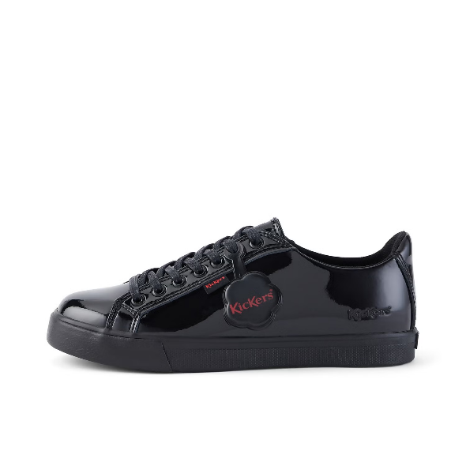 | 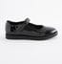  (not enough support for running/sport)
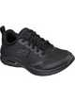 | 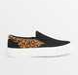  Deck Shoes (not predominantly black and not able to do sport in)
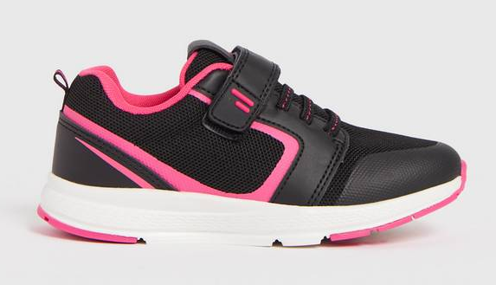  (predominantly black, good support) | 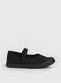  Plimsolls (not enough support)
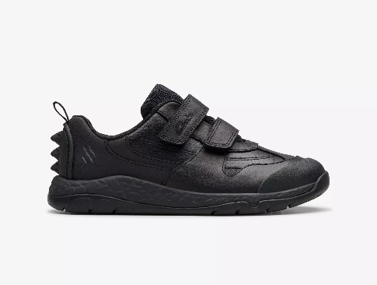 | 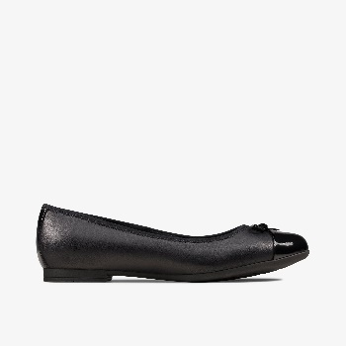  (not enough support)
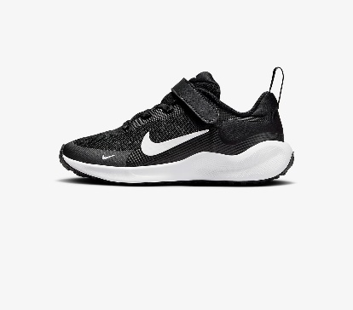  (predominantly black) | 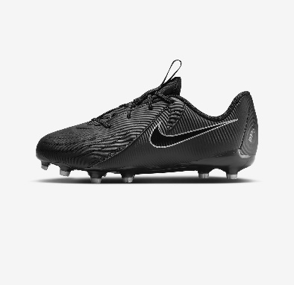  (football boots – no studs allowed)
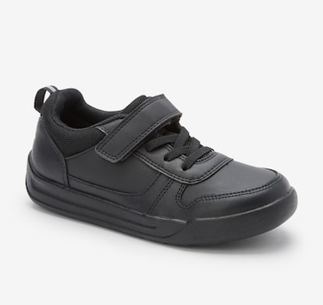 | 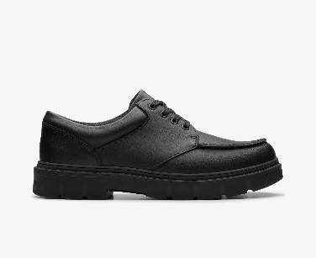  (not suitable for sport/running)

