

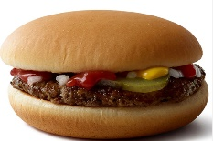
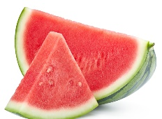
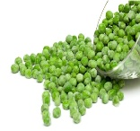
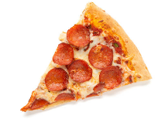
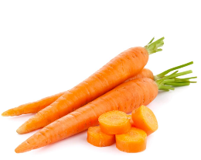
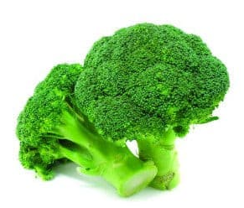


WEEK 1
Friday
MSC Battered Cod
served with chips & peas
Pasta with vegetable sauce or cheese (v)
Ice Cream pot
Yoghurt & Fresh Fruit

Thursday
Homemade Sausage Roll served with new potatoes & beans
Jacket Potato
served with beans or cheese (v)
Chocolate Rice Krispie Cake
Yoghurt & Fresh Fruit

Wednesday
Roast Chicken, stuffing, roast potatoes, Yorkshire pudding & Vegetables
Pasta with vegetable sauce or cheese (v)
Jelly
Yoghurt & Fresh Fruit

Tuesday
Pork Meatballs in a sweet tomato sauce served with Penne Pasta
Jacket Potato
served with beans or cheese (v)
Yoghurt with a selection of toppings
Fresh Fruit

Tuesday
Beef Bolognaise
Quorn Bolognaise (v)
Both served with Pasta & Garlic Bread
Homemade Cupcakes

Monday
Cheese & Tomato Pizza
served with coleslaw
Penne Pasta with vegetable sauce or cheese (v)
Chocolate Chip Cookie
Yoghurt & Fresh Fruit

Lunch
MENU

