
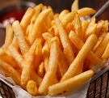
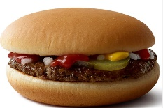
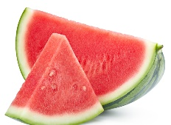
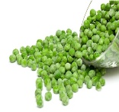
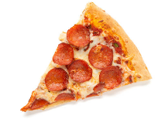
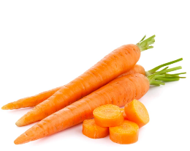
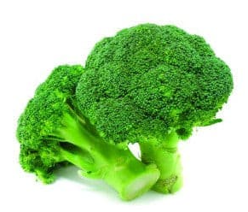
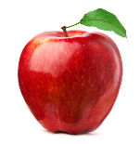

WEEK 2
Thursday
Beef Bolognaise with Penne Pasta
Pasta with vegetable sauce or cheese (v)
Fruit Flap Jack
Yoghurt & Fresh Fruit

Wednesday
Roast Chicken, Stuffing, Roast Potatoes, Yorkshire Pudding & Vegetables
Pasta with vegetable sauce or cheese (v)
Artic Roll
Yoghurt & Fresh Fruit

Tuesday
Cumberland sausage with herb potato wedges & beans
Served with Peas
Pasta with vegetable sauce or cheese (v)
Banana Bread
Yoghurt & Fresh Fruit

Monday
Pasta Bar with a selection of cheese sauce or vegetable sauce & garlic bread
Jacket Potato
Served with beans or cheese (v)
Oat Cookie
Yoghurt & Fresh Fruit

Lunch
Friday
Fish Fingers
Served with Chips & Peas
Jacket Potato
Served with beans or cheese (v)
Shortbread Biscuit
Yoghurt & Fresh Fruit

MENU

