

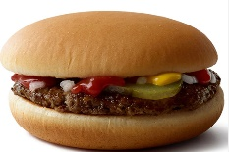
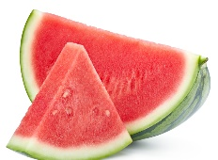
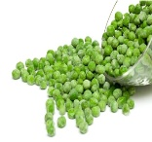


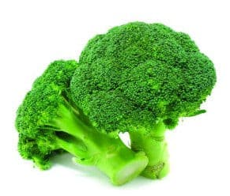


WEEK 3
Monday
Macaroni Cheese served with garlic bread
Jacket Potato
Served with beans, tuna or cheese (v)
Chocolate Chip Cookier
Yoghurt & Fresh Fruit

Lunch
Tuesday
All Day Breakfast with bread & butter
Pasta with vegetable sauce or cheese (v)
Yoghurt with a selection of toppings
Fresh Fruit

Friday
MSC Battered Cod
served with chips & peas
Pasta with vegetable sauce or cheese (v)
Ice Cream pot
Yoghurt & Fresh Fruit

Thursday
Beef Burgers served with new potatoes & sweetcorn
Pasta with vegetable sauce or cheese (v)
Apple crumble & custard
Yoghurt & Fresh Fruit

Wednesday
Roast Chicken, Stuffing, Roast Potatoes, Yorkshire Pudding & Vegetables
Pasta with vegetable sauce or cheese (v)
Chocolate Sponge
Yoghurt & Fresh Fruit

MENU

