Term | Aut 1 |  | Aut 2 | Spr 1 | Spr 2 | Sum 1 | Sum 2
Theme | 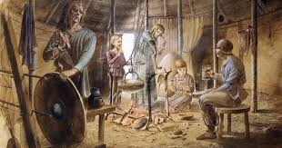  A Journey Back in Time |  |  | 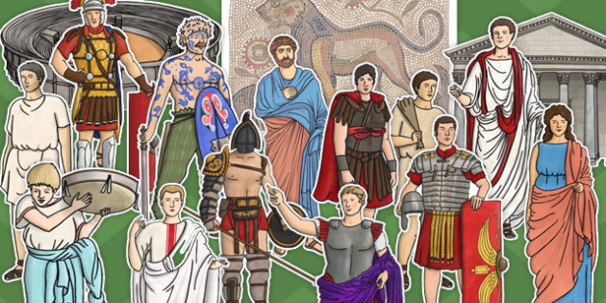  The Rising Romans! |  | 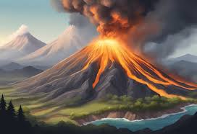  Earth in Action!
Enrichment | Cambridge Zoology Museum/Epping Forest field trip |  |  | Roman Day in school |  | West Stow Anglo Saxon Village
Parents | Assembly/Open Afternoon |  |  | Assembly |  | KS2 Show
English | Information Reports  Narrative  Cinquains |  | Narrative (suspense)  Recount  Remembrance Poetry | Narrative  Explanation Text  Structured Poetry | Narrative  Newspaper Report  Performance Poetry | Narrative  Persuasive Text  Free Verse | Narrative  Playscripts  Poetry on a theme
Mathematics | Place Value  Addition and Subtraction  Multiplication and Division (start) |  | Multiplication and Division (finish)  Calculating with Multiplication and Division  Graphs  Time | Fractions  Calculation Strategies | Length and Perimeter  Measure | Applying Multiplicative Thinking  Angles and Shape | Exploring Calculation Strategies and Place Value
Science | Scientific Enquiry |  | Animals including Humans | Rocks | Forces and Magnets | Plants | Light
Art & Design | Drawing: Power prints |  |  | Painting and mixed media: light and dark |  | Craft and design: Fabric of nature
Design and Technology |  |  | Structure: Pavilions |  | Mechanical systems: mechanical cars |  | Electrical systems: Torches
Computing  (Cycle B) | Microsoft Office 365: Computing Systems and networks 2: emailing |  | Programming Scratch | Video Trailers | Google: creating media: website design | Programming 1: further coding with Scratch | Online safety
Geography | Settlements (DE) |  | Biomes (DE) |  | Italy (DE) | Volcanoes, Mountains and Earthquakes (DE)
History | Would you prefer to have lived in the Stone, Bronze or Iron Age? (Yr 3 only) |  |  | Why did the Romans invade and settle in Britain? |  | How hard was it to invade and settle in Britain? (Anglo-Saxons)
Physical Education | Gymnastics |  | Dodgeball | Swimming | Fitness | Forest School | Athletics
Music | Writing Music Down |  | Playing in a Band | Composing Using Your Imagination | More Musical Styles | Enjoying Improvisation | Opening Night
French | This is me |  | School Days | Birthday Celebrations | Colourful Creatures – animals, colours and size | Fabulous French Food | Gourmet tour of France
‘L4L’  Personal, Social, Economic and Health Education | Introduction  Family and Relationships (L1, L2, L3) |  | Families and Relationships  (L5, L6, L7) | Health and Wellbeing  (L1, L3, L5, L7) | Safety and the changing body  (L1, L4, L7, L8) | Citizenship  (L1, L5, L6) | Economic Wellbeing  (L2, L5)
Religious Education (Cycle A) | Where do Christian religious beliefs come from? |  | How do people express a commitment to a religion or worldview in different ways? | What is philosophy? How do people make moral decisions? | What do Muslims believe about God? | What difference does being a Muslim make to daily life? | Understanding Christianity Unit

