

BIRCHANGER C OF E (VC) PRIMARY SCHOOL

Spirituality Policy
March 2026

Review  Date | Reviewed  By | Date: | Next Review Date
February 2025 | Curriculum Committee | May 2025 | March 2026
March 2026 | FGB | March 2026 | March 2027

Contents

Legal Framework: Links to OFSTED and SIAMS expectations 2
School Statement on Spirituality 3
Aims 4
Organisation 4
Spirituality in Collective Worship 4
Spirituality in Religious Education 5
Spirituality within the Curriculum 5
Spirituality within the Ethos of the Daily Life of the School 6
Recording, Monitoring and Evaluation 7
Roles and Responsibilities 7
Staff Development and Training 7
Additional Support Material 9

Legal Framework: Links to OFSTED and SIAMS expectations
Section 78 of the Education Act 2002 states:
The curriculum for a maintained school or maintained nursery school satisfies the requirements of this section if it is a balanced and broadly-based curriculum which: (a) promotes the spiritual, moral, cultural, mental, and physical development of pupils at the school and of society, and (b) prepares pupils at the school for the opportunities, responsibilities and experiences of later life.

To fulfil their legal obligations under section 48 of the 2005 Education Act, SIAMS inspections make judgments on SMSC education in Church of England and Methodist schools.
The SIAMS Framework (2024) references spirituality implicitly and explicitly in two of the inspector questions:
IQ2: How does the curriculum reflect the school’s theologically rooted Christian vision?
b) How is spiritual development an intrinsic part of the curriculum?
IQ3: How is daily collective worship enabling pupils and adults to flourish spiritually?
a) How do the theologically rooted Christian vision and the Anglican/Methodist foundation of the school shape worship and spirituality in the school?
b) How do partnerships with the DBE and/or MAST, and partnerships with parish/local church/es enhance this?
c) In what ways is the worship life of the school inclusive, invitational, and inspirational?
d) In the context of the school as a Church school, what do pupils and adults understand to be the meaning of spirituality? How does this enhance and enrich collective worship and individuals’ spiritual development?
e) How does the trust contribute to and enhance the school’s worship and spiritual life?
The Church of England Vision for Education has a core desire for ‘Life in all its fullness’ (John 10:10) which requires educating the whole person.

The OFSTED framework 2024 states that provision for pupil’s spiritual includes developing their:
- ability to be reflective about their own beliefs (religious or otherwise) and perspective on life
- knowledge of, and respect for, different people’s faiths, feelings and values
- sense of enjoyment and fascination in learning about themselves, others and the world around them
- use of imagination and creativity in their learning
- willingness to reflect on their experiences

Evidence may be gathered by Ofsted inspectors from anywhere relevant to ensure that schools are promoting SMSC, mental and physical development of pupils at the schools; and prepare pupils at the school for the opportunities, responsibilities and experiences of later life.

School Statement on Spirituality
At Birchanger we want the children to live ‘Life in all its Fullness’ and so have a full spiritual experience. We believe that to talk about spirituality is, essentially, to talk about something which is bigger than ourselves. We understand this language of spirituality begins from a Christian understanding that everyone is a valued creation, individually and uniquely made by God, like pots made by a potter (Isaiah 64:8). Yet, in life things happen that impact on the physical ‘pot’ of life and create cracks that provide a glimpse of something ‘beyond’ the tangible. Christians would view this as an opportunity to relate to the Divine Creator God.
We talk about the following moments which may change our ‘pot’ and when these are filled by the ‘golden glue’ of spirituality:
‘Wow’ moments – when something so good and breathtaking happens
‘Ow’ moments – something sad or difficult happens
‘Now’ moments – a moment of stillness or reflection in the every day
At Birchanger Primary School we use this language and the ideas of ows, wows and nows when exploring relationships with:
ourselves
others
the wider natural world
the beyond, and for some, the invitation to relate to God

Aims

At Birchanger C of E Primary School our vision is ‘Life in all its Fullness’ (John 10). This is communicated through our values of the ‘4Bs, namely, Believing, Being our Best, Being Creative and Belonging. We believe that every child should live life to the full and this includes supporting them in their unique spiritual journeys. At Birchanger we provide children with opportunities to see, connect with and give meaning to life which goes beyond the immediate and the superficial. We aim to help them think about, understand and respond to what they experience in order to widen their perspectives, make sense of the world around them and value peace and harmony.

Organisation
The spiritual growth of pupils is not only dependent on learning in RE and Collective Worship, opportunities for enhancing the spiritual well-being of learners are developed in every aspect of our school life – please see the Rainbow Curriculum for examples.
We support the whole school community to share this responsibility and to develop the shared language of spirituality. Opportunities are available for all to develop spiritually in our supportive and nurturing school inspired by our vision and lived out through our Christian values.
We have identified specific areas which contribute to the spiritual growth of pupils:
collective worship, the whole curriculum, including RE and the general ethos of the school within daily life.

Spirituality in Collective Worship
Collective Worship is the beating heart of Birchanger C of E Primary School. It provides the opportunity for our school community to share experiences, ideas and understanding. It is the context in which the language of spirituality, which we use as a school, is regularly and explicitly shared.
Collective Worship provides the opportunity for pupils to become aware of the importance of reflection and how our positive and negative experiences can be formative. It also provides a real sense of being present (now moments) which are often linked to invitations to pray.
Through daily Collective Worship, pupils are offered a space and a place for hearing the Christian story. They are offered an understanding of worship by being invited to participate in, or observe, Christian spiritual practices such as: prayer, reading and reflection on the Bible and liturgy and are introduced to different musical traditions.
Opportunities to reflect on the wows of life such as beauty and joy of the world are given, as well as time to reflect and empathise with the ow moments of disappointment or pain. Pupils are given time to consider their responsibilities to others and to grow in love and service. Time is given for celebration, both for the accomplishments of school members and to mark seasonal Christian festivals and celebrations in the calendars of other faiths. In this way pupils are offered time to be able to contemplate and develop spiritually. Collective Worship in Birchanger C of E Primary School is invitational, inspirational and inclusive.

Spirituality in Religious Education
The Church of England’s Statement of Entitlement outlines the aims and expectations for Religious Education in Church of England Schools and guides this school’s approach to RE and spirituality.
Learning activities in RE provide for the needs of all pupils, offering a safe space to explore their own religious, spiritual and/or philosophical ways of seeing, living and thinking, believing and belonging. They provide opportunities to engage in meaningful and informed dialogue with those of all religions and worldviews, linking these to pupils’ ideas of spirituality and the language of wows, ows and nows where appropriate.
For further details, please refer to Birchanger C of E Primary School’s Religious Education Policy and The Church of England’s Statement of Entitlement.

Spirituality within the Curriculum
At Birchanger Primary School, driven through our vision of ‘Life in all its Fullness’ we offer a curriculum that is balanced and broadly based and which promotes the spiritual, moral, cultural, mental and physical development of pupils. We promote the children’s spiritual development to support them to be reflective about their own beliefs (religious or otherwise) and perspective on life; knowledge of, and respect for, different people’s faiths, feelings and values; sense of enjoyment and fascination in learning about themselves, others and the world around them. We encourage their use of imagination and creativity in their learning and to be reflective learners.
We do this through:
- an enquiry-based RE Curriculum to promote deeper thinking and reflection
- a PSHE programme which offers opportunity for reflection about themselves
and others, along with units on environmental issues and looking after our
Planet.
- through our Rainbow Curriculum which is a programme of
enrichment designed so that every child can have spiritual experiences.
- the teaching of myHappyMind which is a program designed to support
children's mental health and wellbeing by teaching them the science of
positive
psychology, resilience, and emotional regulation. It helps children build their
self-esteem, practice gratitude and helps to foster positive relationships with
themselves and others.
- through encouraging individual responses to Art, and involvement in projects
such as ‘No Place Like Home’ (Sanctuary Foundation) to support our
refugee children and promote gratitude.
- in Maths through appreciating the wonder of patterns of number and in
nature e.g. symmetry
- in English through reading quality, thought-provoking literature and thinking
about characters’ ow or wow moments, their response to books they have
read (written or verbal)
- through Geography – nurturing an understanding about human impact on
the world (ows) and discussing positive solutions, learning about other
cultures, learning about beautiful places in the world (wows)
- Music – learning about different music and thinking about their individual
responses. How does music make you feel? Which music elicits particular
memories for them?
- Science – developing the children’s curiosity, awe and wonder about the
world including visitors such as Dame Aderin-Pocock
- History – learning about the ‘wow’ and ‘ow’ moments past and present
- PE – children realising the strength and limitations of their bodies, enjoying
the outdoors and physical space
- Forest School – children in touch with nature, experiencing ‘now’ and ‘wow’
Moments
- we also look for unplanned moments which appear in day-to-day life

Spirituality within the Ethos of the Daily Life of the School
In Birchanger C of E Primary School we view spiritual growth as becoming more and more aware of one’s natural, innate spirituality. These opportunities happen throughout each and every day as children deal with delight, disappointment and the chance to be present with themselves.
For this reason, every member of the school community are familiar with the school’s shared language of spirituality and will respond to pupils appropriately.
Throughout the daily life of the school, including lunch times and playtimes, pupils know that their references to wows, ows and nows will be heard and taken seriously. They will be encouraged to reflect on these experiences and be comfortable about talking about the golden glue of spirituality.
Examples of this are:
- Children encouraged to have a ‘now’ moment for reflection if they have
made poor choices (in line with our Positive Behaviour and Anti-Bullying
Policy)
- Through the schools Outdoor Play and Learning Programme (OPAL) which
means the children have opportunities to respond to music, dance, bubbles
and nature every lunchtime.
- Through the use of the Reflection Gazebo which can be used for outdoor
worship and the development of reflection spaces with the Beliefs Council
- A programme of enrichment in our Rainbow Curriculum such as: visitors to collective worship e.g. Woodwind Band Group, Gong Bath in Collective Worship, Retune Session (looking after mental health through music), Zoolab; external trips e.g. Duxford, Gibberd Garden Trip, Residential; special days such as ‘Express Yourself Day’ and wellbeing days on Friendship, Spirituality and Peace; experiences such as Living Chicks.

Recording, Monitoring and Evaluation
The Curriculum Committee review the policy every 3 years in partnership with the Senior Leadership Team and consider any views expressed by parents, children and staff in order to make any changes or recommendations. Recommendations are fed back to the full governing body and are then actioned as appropriate.
Governors ensure that this policy is fully implemented and that practice is consistent with the school’s Christian vision, in line with the school’s monitoring policy and schedule for governors.

Roles and Responsibilities
Recognising there are opportunities for enhancing the spiritual well-being of learners in every aspect of our school life, every member of our staff team is committed to support this spiritual growth wherever appropriate.
The headteacher is responsible for supporting and leading spiritual development in our school, including monitoring opportunities for spiritual growth in collective worship, the whole curriculum (including RE) and the general ethos of the school within daily life,
This role also includes:
- Ensuring personal knowledge and expertise are kept up-to-date by participating in CPD and shared good practice
- Providing and sourcing in-service training for staff as necessary
- Ensuring all staff are familiar with the shared language of spirituality
- Acquiring and organising appropriate resources, managing a budget when necessary
- Monitoring the opportunities for spiritual growth through regular observations and learning walks in both formal and informal contexts, discussions with colleagues and pupil voice
- Contributing to the SIAMS self-evaluation process particularly around Strand 2

Staff Development and Training
We ensure that all staff, including support staff, receive appropriate training and opportunities for professional development, both as individuals and as groups or teams. ECTs and staff who are new to Birchanger Primary School will receive training and support from the staff member identified as leading on spirituality.

This policy is shared on the school’s website and is part of the induction pack for new staff and new governors.
This policy is reviewed every 3 years, or more frequently, as required.

Links with other policies

This Spirituality Policy is linked to:

- RE Policy
- Curriculum Policy
- Teaching and Learning Policy
- Collective Worship Policy

dditional Support Material

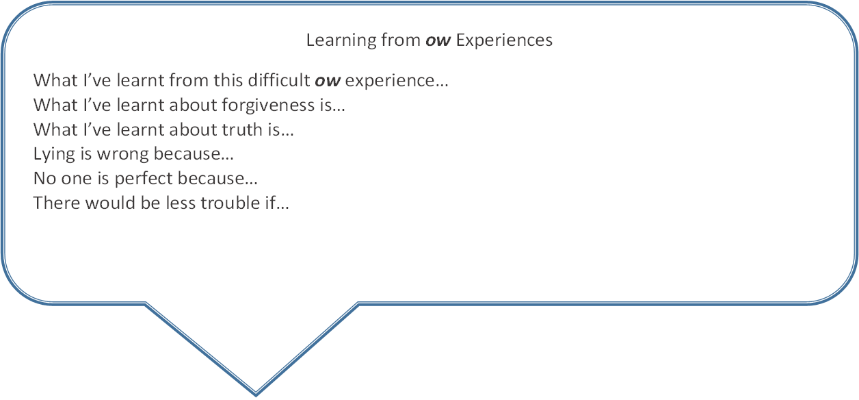

Learning
from

n
ow
Experiences

What I’ve learnt from this
no
w
experience…

What I’ve learnt
about love is…

The world would be a better place if…

I can find peace by…

I think God is like…

One thing I wonder about
God is…

I felt God was near me when…

Silence makes you feel…

Page

