Term | Aut 1 |  | Aut 2 | Spr 1 | Spr 2 | Sum 1 | Sum 2
Theme | 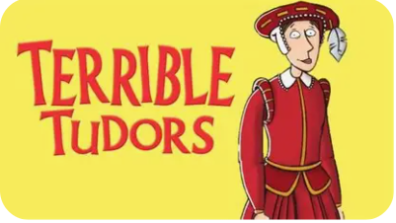  Terrible Tudors |  |  | 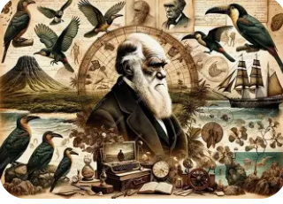  Darwin’s Discoveries |  | Britain, the Blitz and beyond
English | Non-Chronological Reports  Letter  (emotive/informal)  Remembrance Poetry |  | Narrative (suspense)  Formal Letter  Haikus | Narrative  Newspaper Report  Narrative Poetry | Biographies  Balanced Argument  Tanka Poetry | Narrative (portal)  Playscripts  Sonnets | Narrative  Explanation Text  Performance (Poetry/Play)
Mathematics | Place Value  Addition and Subtraction  Multiplication and Division A |  | Fractions A  Multiplication and Division B | Multiplication and Division B (continued)  Fractions B  Decimals A | Area, perimeter and volume  Decimals B  Fractions, decimals and percentages | Ratio  Algebra  Shape | Position and Direction  Statistics  Converting units
Science  (Cycle A) | Electricity |  | Light | Evolution and Inheritance | Animals including humans | Living things and their habitats | Looking after our environment
Art & Design  (Cycle A) | Sculpture and 3D: interactive installation |  |  | Craft and Design: photo opportunity |  | Drawing: expressing ideas
Design and Technology |  |  | Electrical Systems: wobble bots |  | Structures: bridges |  | Textiles: bags
Computing  (Cycle B) | Programming 1: Music |  | Stop-motion animation – option 1: using stop motion studio | Computing systems and networks: search engines | Data handling 1: Big Data 1 | Data handling 2: Big Data 2 | Online safety: Year 6
Geography  (Cycle A) |  |  | North America | Our Connected World |  |  | My Place
History | Tudors |  |  |  | The Industrial Revolution | The Impact of World War II on Great Britain
Physical Education | Volleyball |  | Dodgeball | Dance | Yoga | Rounders | Forest School
Music  (Cycle A) | Express, Inspire and Perform |  | Unlocking Vocal Potential | Music Reimagined | Musical Sketches | Music Remixed | Decoding Sound and Notation
French  (Cycle B) | French transport |  | In my French house | French music celebrations | Verbs in a French week | Visiting a town in France | French sport and the Olympics
‘L4L’  PSHE and RSE  (Cycle A) | Connecting with others: Why are healthy relationships important? |  | The online world: How am I influenced by what I see online? | Citizenship: How can we be in control of our money? | Connecting with others: What does it mean to stand up for myself and others? | Online world: How do I feel about the things I see online? | Staying safe: How can I stay safe as I grow up?  Plus additional RSE content
Religious Education | What does it mean if Christians believe God is Holy and loving? |  | What does it mean to be a Muslim in Britain today? | Why is the Torah so important to Jewish people? | Creation and science: conflicting or complementary? | How can following God bring freedom and justice? | What matters most to Humanists and Christians?

