Term | Aut 1 | Aut 2 | Spr 1 | Spr 2 | Sum 1 | Sum 2
Topic | Marvellous Me  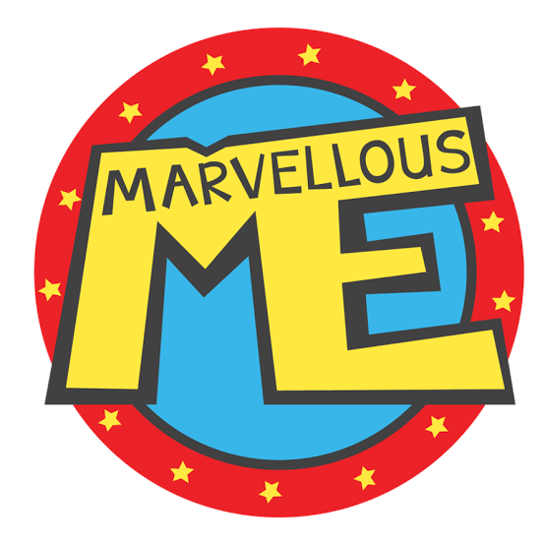 | Look at us glow!  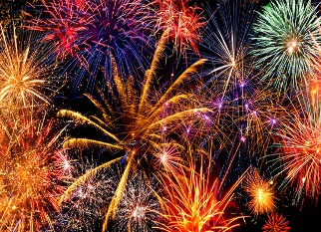 | Our Wonderful World  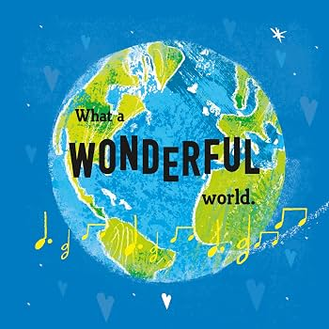 | Ready, Steady, Grow!  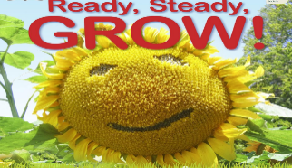 | Let’s set sail!  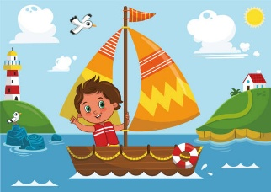 | Life is an adventure  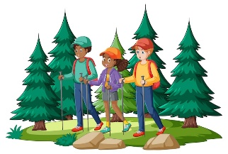
Themes covered | - Starting school – My new class  - Superheroes  - People who help us  - Staying healthy  - Human body  - How have I changed?  - My family  - What am I good at?  - How do I make others feel?  - Being kind / staying safe | Explore a variety of celebrations and  special events | - Space  - Our Solar System  - Looking after our planet  - Dinosaurs  - Fossil Hunters | - Jack and the Beanstalk  - Plants and Flowers  - Spring  - Lifecycles  - Minibeasts  - Planting | - Pirates  - Mermaids  - Marine Life  - Five Oceans  - Layers of the Ocean | - Around the World  - Continents  - Animals  - Habitats  - Climate  - Travel
Key Events | - Autumn Trail  - Harvest Time  - Birthdays  - Halloween | - Bonfire Night  - Remembrance Day  - Thanksgiving  - Birthdays  - Christmas | - Valentine's Day  - Lunar New Year  - Pancake Day | - World Book Day  - Mother's Day  - St. David's Day  - Easter | - St George's Day  - World Bee Day  - World Turtle Day  - Elmer Day  - Sports Day | - National Dinosaur Day  - World Ocean Day  - World Giraffe Day  - Shark Awareness Day
Big Ideas | - I am special and unique  - I belong here  - I can talk about myself  - and my feelings  - I am learning new  - routines  - My family is important  - to me | - We celebrate together  - Light shines in dark times  - People remember important events  - Traditions are special  - Everyone celebrates differently | - The world is amazing and full of wonder  - We can explore things we can't see up close  - The past is fascinating  - We must look after our planet  - We can ask big questions | - Things grow and change  - Living things need care  - Spring brings new life  - We can nurture and protect  - Stories can inspire exploration | - The world is made up of oceans  - The sea is full of life  - We can explore imaginary and real worlds  - Water environments are important  - Adventure stories inspire creativity | - The world is big and diverse  - People live differently around the world  - Animals adapt to where they live  - Climate affects habitats  - Travel connects us
Communication & language | Focus:  - Talking about self  - Listening to others  - Following simple routines  - Learning classroom vocabulary  Key Vocabulary:  me, my, mine, name, family, home, happy, sad, kind, share, listen, turn  Adult Modelling:  - "Tell me about…"  - "I noticed you…"  - "How did that make you feel?" | Focus:  - Talking about past events  - Sharing family traditions  - Learning celebration vocabulary  - Listening to others' experiences  Key Vocabulary:  celebrate, remember, special, light, candle, fireworks, family, thank you, birthday,  gift, together  Adult Modelling:  - "In our family we…"  - "Some people celebrate by…"  - "How do you celebrate?" | Focus:  - Asking questions ("why?”, “how?")  - Using new topic vocabulary  - Retelling information  - Listening to non-fiction  Key Vocabulary:  planet, space, rocket, astronaut, dinosaur, fossil, extinct, Earth, recycle, protect, environment  Adult Modelling:  - "I wonder why…"  - "What do you think might happen if…?"  - "How could we find out?" | Focus:  - Sequencing stories  - Explaining changes  - Using topic-specific vocabulary  - Asking investigative questions  Key Vocabulary:  grow, seed, root, stem, leaf, flower, plant, lifecycle, caterpillar, chrysalis, minibeast,  soil, water, sunlight  Adult Modelling:  - "What do plants need to grow?"  - "What happened first?"  - "What has changed?" | Focus:  - Rich descriptive language  - Storytelling and role play dialogue  - Explaining facts  - Asking investigative questions  Key Vocabulary:  ocean, sea, pirate, treasure, map, ship, anchor, coral, reef, wave, tide, deep, shallow, surface  Adult Modelling:  - "What might happen next?"  - "How do we know that?"  - "Describe what you can see under the sea.” | Focus:  - Describing differences and similarities  - Using geographical vocabulary  - Asking and answering questions  - Sharing personal travel experiences  Key Vocabulary:  continent, country, climate, habitat, desert, rainforest, polar, jungle, travel, passport,  journey, culture  Adult Modelling:  - "How is this place different from ours?"  - "Why might that animal live there?"  - "What would we need to pack?"
Personal, social & emotional development | Focus:  - Settling into a new environment  - Making friendships  - Understanding feelings  - Building confidence  Key Learning:  - I can say my name  - I can choose an activity  - I can begin to regulate with support | Focus:  - Understanding similarities and differences  - Turn-taking during celebrations  - Managing excitement  - Talking about gratitude  Key Learning:  - I can say what makes something special  - I can respect other people's traditions  - I can talk about my feelings | Focus:  - Working collaboratively (rocket building, dig sites)  - Taking care of shared environment  - Developing resilience through problem solving  - Key Learning:  - I can work as part of a team  - I can care for our classroom  - I can share my ideas | Focus:  - Responsibility (watering plants)  - Caring for living things  - Working cooperatively in planting  - Patience (waiting for growth)  - Key Learning:  - I can care for something  - I can take turns  - I can notice change | Focus:  - Cooperative role play  - Negotiation (treasure sharing!)  - Respecting real marine life  - Managing excitement in imaginative play | Focus:  - Respecting diversity  - Celebrating different cultures  - Transition confidence  - Independence  - Key Learning:  - I can talk about different places  - I can respect others  - I am ready for my next adventure
Physical Development | Focus:  - Fine motor baseline  - Name writing attempts  - Scissor skills  - Gross motor routines (lining up, stopping, listening) | Focus:  - Fine motor through craft (poppies, cards, decorations)  - Scissor progression  - Dough disco / finger strength  - Gross motor – movement to celebration music | Fine Motor:  - Small world manipulation  - Mark making labels  - Cutting planet shapes  Gross Motor:  - Space movement games  - Dinosaur stomp obstacle courses  - Outdoor exploration | Fine Motor:  - Digging and scooping soil  - Seed planting  - Threading minibeast crafts  - Scissor work (petals, leaves)  Gross Motor:  - Bean stalk climbing obstacle course  - Minibeast movement games | Fine Motor:  - Treasure map mark making  - Cutting fish shapes  - Threading beads for pirate necklaces  Gross Motor:  - "Walk the plank" balance  - Pirate obstacle courses  - Wave movement dance | Fine Motor:  - Passport stamping  - Map drawing  - Animal art  Gross Motor:  - Animal movement games  - "Airport security" obstacle course  - Weather movement (wind, rain, sun)
Literacy | - Name recognition  - Mark making for meaning  - Drawing self portraits  - Line and pattern | - Retelling celebration stories  - Card writing  - Label writing  - Listening for rhythm and rhyme  - Begin to write some CVC words | - Non-fiction texts  - Labelling diagrams  - Writing simple facts  - Story innovation/maps | Core Text Idea: Jack and the Beanstalk  - Story sequencing  - Story mapping  - Giant's Jobs List  - Writing simple instructions -  - How to plant a seed | Core Text Ideas  - The Night Pirates  - Sharing a Shell  - The Rainbow Fish  Focus:  - Story maps  - Character description  - Treasure hunt instructions  - Fact cards about sea creatures | - Fact writing  - Animal labels  - Travel diaries  - Postcards from around the world
Mathematics | - Matching and sorting  - Comparing amounts, size, mass and capacity  - Exploring, copy & continuing and creating simple patterns | - Find 1,2,3,4,5  - Subitise 1,2,3,4,5  - Represent 1,2,3,4,5  - Composition of 1,2,3,4,5  - 1 more and 1 less  - Circles and triangles  - Shapes with 4 sides | - Introduce 0  - Find, subitise and represent 0-5  - 1 more and 1 less  - Composition of 0-5  - Explore and compare mass and capacity  - Find a balance  - Find, represent and understand the composition of 6,7,8  - 1 more and 1 less  - Odds and evens  - Double to 8  - Combining 2 groups | - Explore and compare length and height  - Talk about time  - Order & sequence time  - Find, compare, represent subitise and understand composition of 9 & 10  - 1 more and 1 less  - Bonds to 10  - Arrangements of 10  - Doubles to 10  - Odds and evens  - 3D shape | - Build numbers beyond 10  - Continue patterns beyond 10  - Verbal counting beyond 20  - Verbal counting patterns  - Adding & subtracting  - Rotating, manipulating and explaining 2D shape arrangements  - Compose and decompose shapes  - 2D shapes pictures  - 2D shapes within 3D shapes | - Sharing and grouping  - Doubles  - Repeating patterns  - Pattern rules  - Position and direction  - Mapping  - Making connections
Understanding the world | - Families and homes  - Past and present - baby photos  - Our classroom community  - Simple maps - home to school  - Feelings and emotions  - People who help us | Bonfire Night  - Why we have fireworks  - Safety discussions  Remembrance Day  - Poppies as a symbol  - Being thankful  Thanksgiving  - Gratitude  - Harvest links  Birthdays  - Time passing  - Growing older  Christmas  - Traditions  - Nativity story | Space  - Earth is a planet  - The Sun gives us light  - The Moon changes shape  - Astronauts explore space  Dinosaurs  - Lived a long time ago  - Different sizes and types  - Fossils help us learn  - Some were herbivores / carnivores  Looking After Our Planet  - Recycling  - Reducing waste  - Caring for animals  - Keeping our classroom tidy | Plants and Flowers  - What plants need to grow  - Parts of a plant  - Seasonal change (Spring)  - Observational drawing  Lifecycles  - Butterfly lifecycle  - Frog lifecycle  - Bean and Sunflower lifecycle  - Sequencing change  Minibeasts  - Habitats  - Similarities and differences  - Respecting living creatures  - Outdoor exploration | The Five Oceans  Introduce simply:  - Pacific  - Atlantic  - Indian  - Southern  - Arctic  Layers of the Ocean:  - Sunlight Zone (surface)  - Twilight Zone  - Midnight Zone  Focus on:  - Light vs dark  - Which animals live where  - Why it gets colder and darker  Marine Life  - Fish  - Sharks  - Octopus  - Jellyfish  - Turtles  - Whales  Discuss:  - Habitats  - Why we must protect oceans  - Plastic pollution link (nice link back to Spring One)  Pirates & Mermaids  - Fiction vs non-fiction  - Maps  - Boats and transport  - Story invention | Continents  Introduce:  - Africa  - Europe  - Asia  - North America  - South America  - Australia  - Antarctica  Animals and Habitats  - Rainforest – monkeys, parrots  - Desert – camels  - Savannah – lions, elephants  - Polar – polar bears, penguins  - Ocean – whales  Climate  - Hot  - Cold  - Wet  - Dry  Simple cause and effect:  - "Polar bears have thick fur because...
Expressive Arts & Design | - Self-portraits (paint, collage, loose parts)  - Family role play  - Singing name songs  - Exploring mirrors | - Whole class firework painting  - Salt painting fireworks  - Loose parts poppy pictures  - Collage  - Nativity songs/carols  - Nativity acting | - Galaxy splatter painting  - Clay fossils  - Junk modelling rockets  - Recycled art  - Dinosaur small world | - Printing with vegetables  - Flower collage  - Clay minibeasts  - Role play giant's castle  - Outdoor mud kitchen "garden centre" | - Ocean layered art  - Treasure chest junk  - modelling  - Shell printing  - Mermaid tail collage  - Pirate ship construction | - Continents and oceans song  - Animal collage  - Shoebox habitats
‘L4L’  PSHE and RSE | Self-regulation: My feelings | Building relationships: Special relationships | Managing self: Taking on challenges | Self-regulation: Listening and following instructions | Building relationships: My family & friends | Managing self: My wellbeing
Religious Education | Why is the word God so important to Christians?  Christianity | Why do Christians perform nativity plays at Christmas?  Christianity | Why do Christians put a cross in an Easter Garden?  Christianity | What puzzles you about the Easter story?  Christianity | What happens in a place of worship?  Christianity/ Judaism | Why are stories important to Muslims?  Islam

